**Final Project Report**

**Optimization of Eradication of Ebola Virus Disease**

To:

**Professor Timothy Reluga**

From:

**Jiaqi Li**

**Introduction**

In this project, the main goal is to optimize the eradication of the EVD (Ebola Virus Disease) during the outbreak in Guinea in 2014 and make some models that considers effective medicine and vaccine. The factors in a simple model of spread of Ebola in 2014 mainly consider susceptible population, infected patients, and death from Ebola, while a more complex and realistic model will consider isolation and survivors also as significant factors in addition to the simple model. We also want to ask the question that if we have effective medicine for Ebola treatment and effective vaccine for disease prevention, how would the spread of Ebola change in 2014. The main method for this project is using the compartmental model. Problems concerning the model and real-world situations will also be addressed in this project. In addition, all models made in this project are based on the data of Guinea, recorded by WHO and posted as an open source to public by Centers for Disease Control and Prevention.

**Background**

In December 2013, a disease called Ebola starts to spread in small village of Guinea where nobody had ever realized how fatal such disease can be until March 2014. WHO reported that the origin of this Ebola disease was very likely from wild animals, and the index case of this disease was identified as an 18 years old boy who died from it. As such disease spread rapidly throughout the land of West Africa, it becomes the Ebola epidemic. At the beginning of the epidemic, there is no effective medicine that can cure infected patients and no effective vaccine that can prevent people from getting infected. In this situation, more than ten thousand of people died from Ebola during 2014 to 2015. The only thing that an Ebola patient can do is to get isolated so that less people would be infected by Ebola. Fortunately, scientists successfully developed vaccine that can prevent people from getting Ebola with almost 100% effectiveness in December 2016. Study of special medicine for Ebola treatment is also in process. For now, very few cases of Ebola are found, and the spreading of the disease is under control.

In this project, we want to know how the spreading of Ebola would behave if we have effective vaccine and medicine at the very beginning of the outbreak in Guinea. Also, questions like what people would need to do and what difficulties people would need to face to reduce total number of infection and death would also be interesting to us. To answer these questions, we made a model and perform several simulations that can give us a better view when we are trying to do analysis. The following content of this report will address what methods we use, what models we make, what results we have come up with, and what probable answers for our questions would be.

**Methods and Results**

At the beginning, we want to simulate the spread of the Ebola in Guinea. The most basic model is shown as following:

I

$$δ$$

$$v$$

D

S

In this model, S represents the Susceptible Population, I represents the Infected Patients, D represents the Death from Infected Patients D, $v$ is the spread rate of the Ebola, and $δ$ is the death rate of the Ebola patients. The parameter $v$ is not a constant since the spread rate of the disease will depend on infection rate and exposure rate. Thus, we make $v=β \frac{I+D}{I+S+D}$ where $β$ is the chance of getting infected if one is exposed to infectious disease (infection rate) and $\frac{I+D}{I+S+D}$ is the chance of being exposed to infectious disease. Here, we assume that infected patients and death are infectious to susceptible population. The system of differential equations can be written as:

$$\left\{\begin{aligned}\frac{dS}{dt}= -vS \\ \frac{dI}{dt}= vS-δI \\ \frac{dD}{dt}=δI \end{aligned}\right.$$

Then, we try to fit the data with this model so that we can develop a more complex model base on this simple model. In this simple model, we can fit the infection curve well to the data with $β=0.0676$, $δ=0.0225$, $N=3156$ where N is the population of susceptible population at the beginning. However, the maximal number of total death that our model predicts is much larger than the actual total death and the maximal number of total infected people. To improve our model, we will add two more variables to make the model more realistic and we will also adjust the values of the parameters so that our model can fit the data. The two variables that we consider as significant factors next are Immune Population and Isolated Patients, represented as M and H:

D

S

I

$$δ$$

$$v$$

$$μ$$

$$λ$$

$$σ$$

$$ω$$

$$θ$$

M

H

In this model, we add five more parameters:

$ω$: discover rate of naturally immune people

$σ$: self-recover rate from infected patients

$λ$: isolation rate from infected patients

$μ$: death rate from isolated patients

$θ$: recover rate from isolated patients

Unites of all parameters are in $×$*100 percentage of corresponding population per day* ( $β, ω, σ, δ, λ, μ, θ$ has corresponding population of S,S,S,S,S,S,H).

In this model, we can obtain a new system of differential equations as following:

$$\left\{\begin{aligned}\frac{dS}{dt}= -vS-ωS \\ \frac{dI}{dt}= vS-δI-σI-λI \\ \frac{dD}{dt}=δI+μH \\ \frac{dM}{dt}=ωS+σI+θH \\ \frac{dH}{dt}=λI-θH-μH\end{aligned}\right.$$

For variable H, isolated patients will receive necessary medical care that can slow the deterioration rate of Ebola. The self-recover rate, $σ$, is very small because very few people can recover by themselves when they are infected. Also, we will still use the formula $v=β \frac{I+D}{I+S+D}$ because people belongs to variable M will be immune to Ebola for life and will not infect others, and isolated people will not be able contact any others outside the isolation camps, which means they will not infect other susceptible people. By fitting the model into the data, we have $β=0.08, ω=0.000000001, σ=0.00001, δ=0.07, λ=0.06, μ=0.001, θ=0.01, N=3156$ where N is the susceptible population at the beginning. The initial condition (S,I,D,M,H) are (3156,648,430,22,87,648). In this model, $ω$ is extremely small since very few people are found to be naturally immune to Ebola during the outbreak in 2014. $μ$ is relatively small even though isolated patients receive better medical care because Ebola was still very fatal even with medical care during the outbreak in 2014. It is hard for us to estimate the value of $λ$ since there are many factors that can influence infected patient getting isolated, such as some patient were not willing to be isolated and medical supplies were also very limited. Thus, we set $λ=0.06$, which can help our model fit the data well.

The simulation with fitting data plots start from August, 2014 are presented as following:

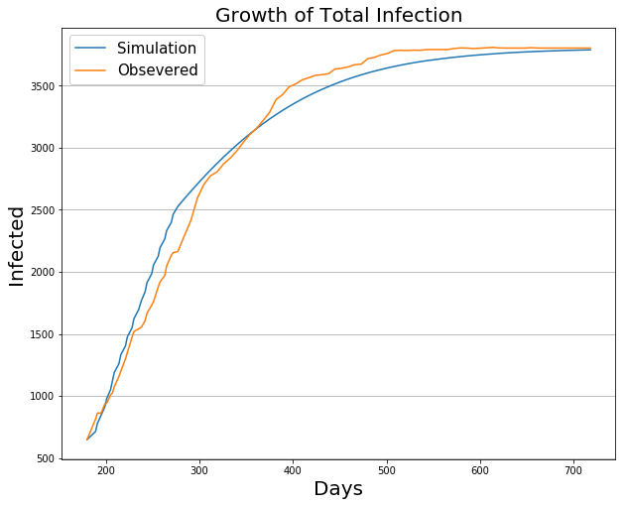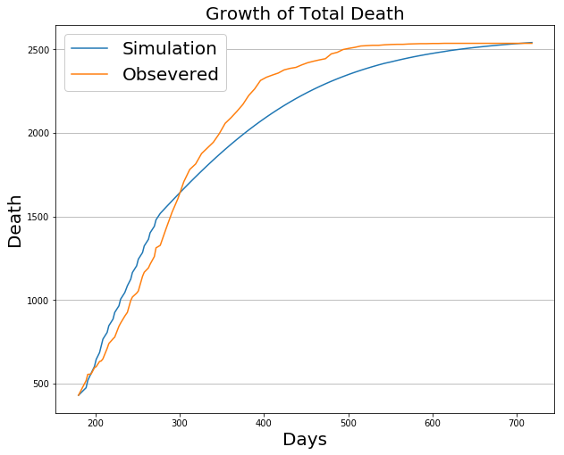 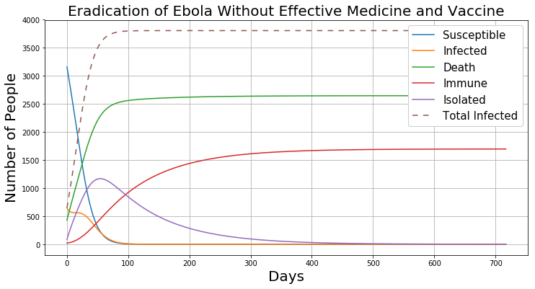

Figure 1

As we can see, this model performs a fair simulation of growth of total infection and total death. Since we fit the data starting from August 2014, there are already 648 infected patients and 430 deaths. When we look at the full information plot of eradication of Ebola (Eradication of Ebola Without Effective Medicine and Vaccine), nearly all susceptible people are infected in about 3 months (90 days). Many infected patients are isolated in 50 days, which can control the spread of the disease. Less and less people are infected every day as people fighting against the disease. The number of people who are immune to Ebola also increase and continue to grow in about 400 days.

Since the prediction we made shown by figure 1 starts from August 2014 when there were already a lot of Ebola patients in Guinea, we also want to take a look at the simulation that performs a full cycle of the spread of the disease. Thus, we want to perform a simulation that starts from the very beginning of the outbreak when only 1 person is infected by Ebola. The following plot gives us a visualization of such simulation:

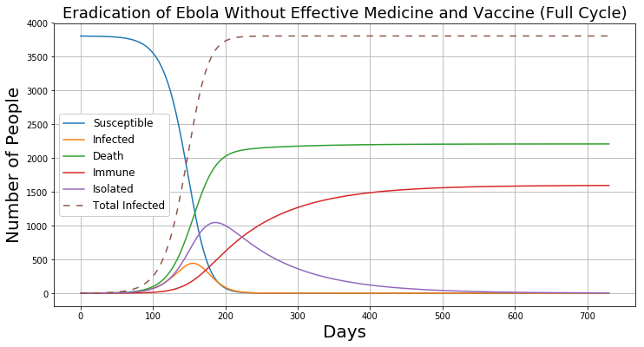

Figure 2

From this plot, we can see that each curve has the shape that is very similar to the eradication plot in figure 1 except that this plot is made with initial condition (S,I,D,M,H) at (3804,1,0,0,0,1). We set S = 3804 because the maximal number of infection recorded by WHO is 3804, which means the minimal size of susceptible population should be 3804. We also find that after 3 months (about 90 days) when the index case (the first discovered case) of Ebola infection was identified in December 2013, the actual outbreak of Ebola started. This shows that our model performs a very realistic simulation of the Ebola outbreak in 2014 because the index case of Ebola is in December 2013 and the outbreak started in March 2014.

Next, we want to optimize the eradication of Ebola by assuming that:

1. Effective medicine specially for Ebola Virus Disease is available at the beginning of the outbreak.
2. Effective vaccine specially for Ebola Virus Disease is available at the beginning of the outbreak.
3. People are not willing to pay for Ebola vaccine until new infected cases of Ebola are confirmed and the disease has started to spread.
4. Medicine are given to patients freely and vaccine are sold at a very low price to people in Guinea with sponsor from WHO so that most of the Ebola patients can get fairly effective medical treatment and large percentage of the Guinea’s population can get vaccination.
5. Patients in Guinea are willing to seek for medical help and accept medical treatments.

With these assumptions, we need to make some change to the parameters of our model. One very import change of the parameter is $ω$. Since vaccine is available to Guinea, people will seek for vaccination to prevent getting infected by Ebola. In this situation, $ω$**becomes the vaccination rate of the susceptible population**. Also, since effective medicine is available for patients, $θ$ will also increase. Based on the report of the “Final trial results confirm Ebola vaccine provides high protection against disease” by WHO, the VSV-EBOV vaccine, the first proven vaccine against Ebola virus, can be 80% to 100% effective. Based on that, we assume that medicine for Ebola could also be really effective if patients receive medical treatment in early stage of Ebola disease. Thus, **we set $θ=0.6$ so** that survival chance for Ebola patients increases significantly.

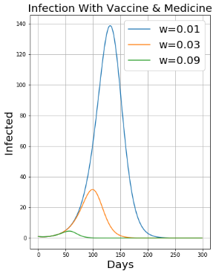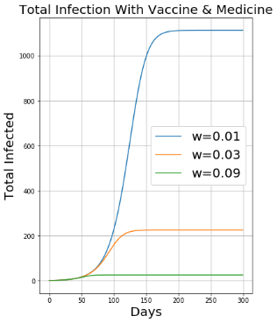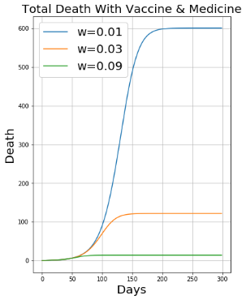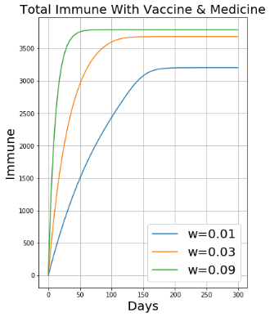

Figure 3

By observing the plot above, we can tell that if $ω=0.01$, there will still be about 600 people died from Ebola, more than 1000 people will be infected and it will take more than 3 months for people to control the spread of the disease. When $ω=0.09$, number of people getting infected with Ebola and number of death will be very small and almost all susceptible people get vaccine in 50 days.

Finally, we will take a look at the full plot concerning all variables for $ω=0.09$ and $θ=0.6$:

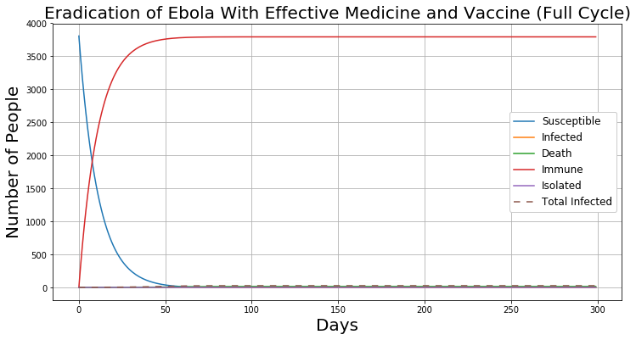

Figure 4

From this plot, we can see that a lot of susceptible people will be immune to Ebola in one month. Within 3 months, all susceptible people will be immune to Ebola. Achieving such success will significantly reduce the death and have fantastic control over the spread of the disease.

**Conclusion**

We constructed a model that can perform a fairly realistic simulation of the Ebola epidemic. The main factors of our model are susceptible population, infected patients, death from Ebola, isolated patients, and immune population. When we add our assumptions that effective medicine and vaccine are available during the epidemic to our model, we make some change to the parameters of the model so that we will be able to see how the spreading of the Ebola change in Guinea. With different vaccination rate in susceptible population, we can see that numbers of infection of Ebola and death from Ebola decrease significantly. At vaccination rate equal to 0.09, more than 90% of the susceptible population are immune to Ebola in about one month. The number of Death from Ebola becomes very small, which means that if one is infected with Ebola, his or her chance of surviving significantly increases. In addition, people can eradicate Ebola virus once it rises within 3 months as shown in the figure 4. We can keep increasing $ω$ until we have very small numbers of infection and no death. However, we may not reach such efficiency to give 9% susceptible population vaccine per day when the susceptible population widely spread through 13 cities in Guinea. Based on the population census in 2014, there are 2,479,894 people living in cities that were under attached by Ebola, while only 0.15% of these people are considered susceptible population. Thus, even though medicine and vaccine are available for Guinea people when Ebola appears, governments of Guinea need to act fast enough to deliver enough vaccine and medicine to different locations throughout the country. Also, people in Guinea not only need to be well informed about how fatal Ebola can be so that people are willing to get vaccination as soon as possible, but also need not to be over panic about the disease. If all the suggestions addressed above can be achieved, the efficiency and intensity of eradication of Ebola can be optimized.

**Discussion**

Based on our study, our model for the simulation of the spreading of Ebola dose a fairly good job in fitting the infection curve, but it is not very good in fitting the death curve. This probably because we do not have a proper death rate in model and we are missing some important factors of the model. When constructing the model, it is hard to estimate all the parameters if we want to make it realistic. Some of the parameters, like the chance of being isolated when a person is infected, do not have any resource for us to estimate their values. Thus, many parameters are estimated based on a reasonable guess and available data offering by authoritative organizations like WHO (World Health Organization) and CDC (Center of Disease Control). Even though we can take more time to make extremely comprehensive consideration of many other factors that influence the Ebola outbreak, there will still be some factors hiding in the nature that we fail to take account of. Also, we may not necessary need such accuracy in making prediction of natural phenomenon. All we need is a fairly good trend that can tell us what is about to happen. The truly important idea for our model is not about how to fit the data excellently and how to make the model extremely complex. Instead, our goal is to see what will happen if we have a truly effective way to prevent and cure Ebola based on a fairly constructed model.

Moreover, if we do want to consider other factors that are also important for constructing models for eradication of Ebola, we could think about the following facts:

1. Some people buried bodies infected with Ebola secretly. If the bodies were buried near water source or food plans, the virus could easily infect other people by water or be carried to other places by food.
2. Some people who already get infected by Ebola may be afraid to ask for help, because they know they will be isolated with other patients and they may die eventually.
3. Some of the patients think that they are getting seasonal flu instead of Ebola, which makes unwilling to report their illness. When these people become infectious, they are very likely to infect other healthy people.

These factors will need us to take consideration of ways of transmission of the virus, geographic features and public psychological elements. With these factors, our model will be much more complex and accurate.

**Reference**

Tarik, Jasarevic. “Final Trial Results Confirm Ebola Vaccine Provides High Protection against Disease.” *World Health Organization*, World Health Organization, 23 Dec. 2016, www.who.int/mediacentre/news/releases/2016/ebola-vaccine-results/en/.

Ana, Maria, et al. “Efficacy and Effectiveness of an RVSV-Vectored Vaccine in Preventing Ebola Virus Disease: Final Results from the Guinea Ring Vaccination, Open-Label, Cluster-Randomised Trial (Ebola Ça Suffit!).” *THE LANCET*, 22 Dec. 2016, www.thelancet.com/journals/lancet/article/PIIS0140-6736(16)32621-6/fulltext.

“Ebola: Mapping the Outbreak.” *BBC News*, BBC, 14 Jan. 2016, www.bbc.com/news/world-africa-28755033.

“Origins of the 2014 Ebola Epidemic.” *World Health Organization*, World Health Organization, 25 Sept. 2015, www.who.int/csr/disease/ebola/one-year-report/virus-origin/en/.

“Ebola (Ebola Virus Disease).” *Centers for Disease Control and Prevention*, Centers for Disease Control and Prevention, 17 Feb. 2016, www.cdc.gov/vhf/ebola/outbreaks/2014-west-africa/cumulative-cases-graphs.html.